Test Simulationsmodell Wald

# Goal

The goal’s model is to produce a realistic workload for our experimental simulation system until the biologically founded real model is available.

# Time model

One Tick = One Day, 360 day / year, 30 days / month

# Model elements

## Tree

Is the center of the model. Can be a small seedling, small tree or a tall tree.

Attributes

|  |  |  |  |
| --- | --- | --- | --- |
| **name** | **type** | **value range** | **description** |
| id | Int | 0 - 2^32 | unique identifier |
| diameter | float | 0 < diameter | The diameter of the tree in m |
| height | float | 0 < height | The tree’s height in m |
| fitness | float | 0 < fitness < 100 | A value indicating the overall health of the tree (in %) |

Every tick a tree grows. Diameter and height growth are calculated separately.

### Growth calculation

d = diameter

h = height

GmaxH = maximum height

GmaxD = maximum diameter

GparK = growth coefficient

#### Diameter

$$d_{t+1}=d_{t}+GparK (GmaxD- d_{t})$$

#### Height

$$h_{t+1}=h_{t}+GparK (GmaxH- h_{t})$$

Parameters for Anogeissus leiocarpa: GparK = 0.18, GmaxH 15-30m, GmaxD=325/3.14

### Death

Can die of age ()

### Seed dispersal

Seeds are dispersed in the period between April 15th and May 30th

Model: tree position is (approximate) center of 2-dimensional gaussian distribution

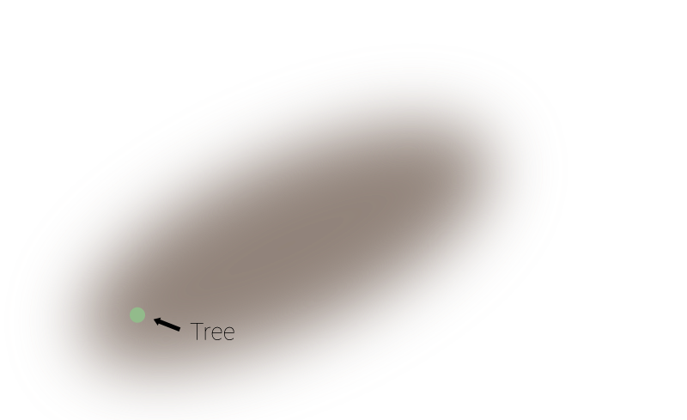

$$p_{d}=\frac{e^{-\frac{{\left(x-μ\right)}^{2}}{2σ^{2}}}}{\sqrt{2π}σ} where d ∈\left\{xAxis, yAxis\right\}$$

Success rate for ~1.5 mio. seeds 0.3% = ~45000 seeds spread

Generate positions using inverse transform sampling (solve for x) –>

$x= μ±\sqrt{-\ln{{(p}_{d}\sqrt{2π} σ)} 2σ^{2}}$ (not exactly, dead spot around 0. Has to suffice for now :()

## Village

Attributes

|  |  |  |  |
| --- | --- | --- | --- |
| **name** | **type** | **value range** | **description** |
| id | Int | 0 - 2^32 | unique identifier |
| Population | Int | 1-2^32 | Amount of Villager with excess to the forest. |
| VillagePosition | Vektor2D | X & Y inside global Coordinates |  |
| Influence Radius | Number | Position – All map elements | Radius in which the Population searches for wood |

#### Population

This Value represents the size of the Village

VillageProportions

This Value describes the position and the radius of this village. Inside this area no seed can be placed.

#### Influence Radius

This area describes the area in which villagers from this village search for trees to satisfy their desire for wood.

## Villager

Attributes

|  |  |  |  |
| --- | --- | --- | --- |
| **name** | **type** | **value range** | **description** |
| id | Int | 0 - 2^32 | unique identifier |
| HomeVillageID | Int | 0 - 2^32 | unique identifier of the HomeVillage |
| WoodStorage | Int | 0 - 2 ^32 | Value that describe how much Wood the Villager have stored. Decrease over Time. |
| DailyWoodUsage | Int | 0 - 2^32 | Amount of Wood the Farmer consumes per day. |
| WoodCuttingLocation | Vektor2D | Point(X,Y) in HomeVillageRange | Around this point the Villager will cut down new Tree, if he desires more wood. |

How much wood can woodchuck chuck if a woodchuck could chuck wood?

#### WoodStorage

Decrease over Time, to simulate the usage of wood (DailyWoodUsage). If this value is lower than Zero the Villager will move to his WoodCuttingLocation and cut wood.

Every tree that is cut down by this villager increases that value.

#### DailyWoodUsage

In the first iteration of the model this value combines all the usage of wood (e.g. selling, burning, building Houses, …)

#### WoodCuttingLocation

Villagers seek the location of this Waypoint to cut Trees for their wood usage. This Waypoint is randomly calculated after the initialization of the Villager and after each wood cutting trip.